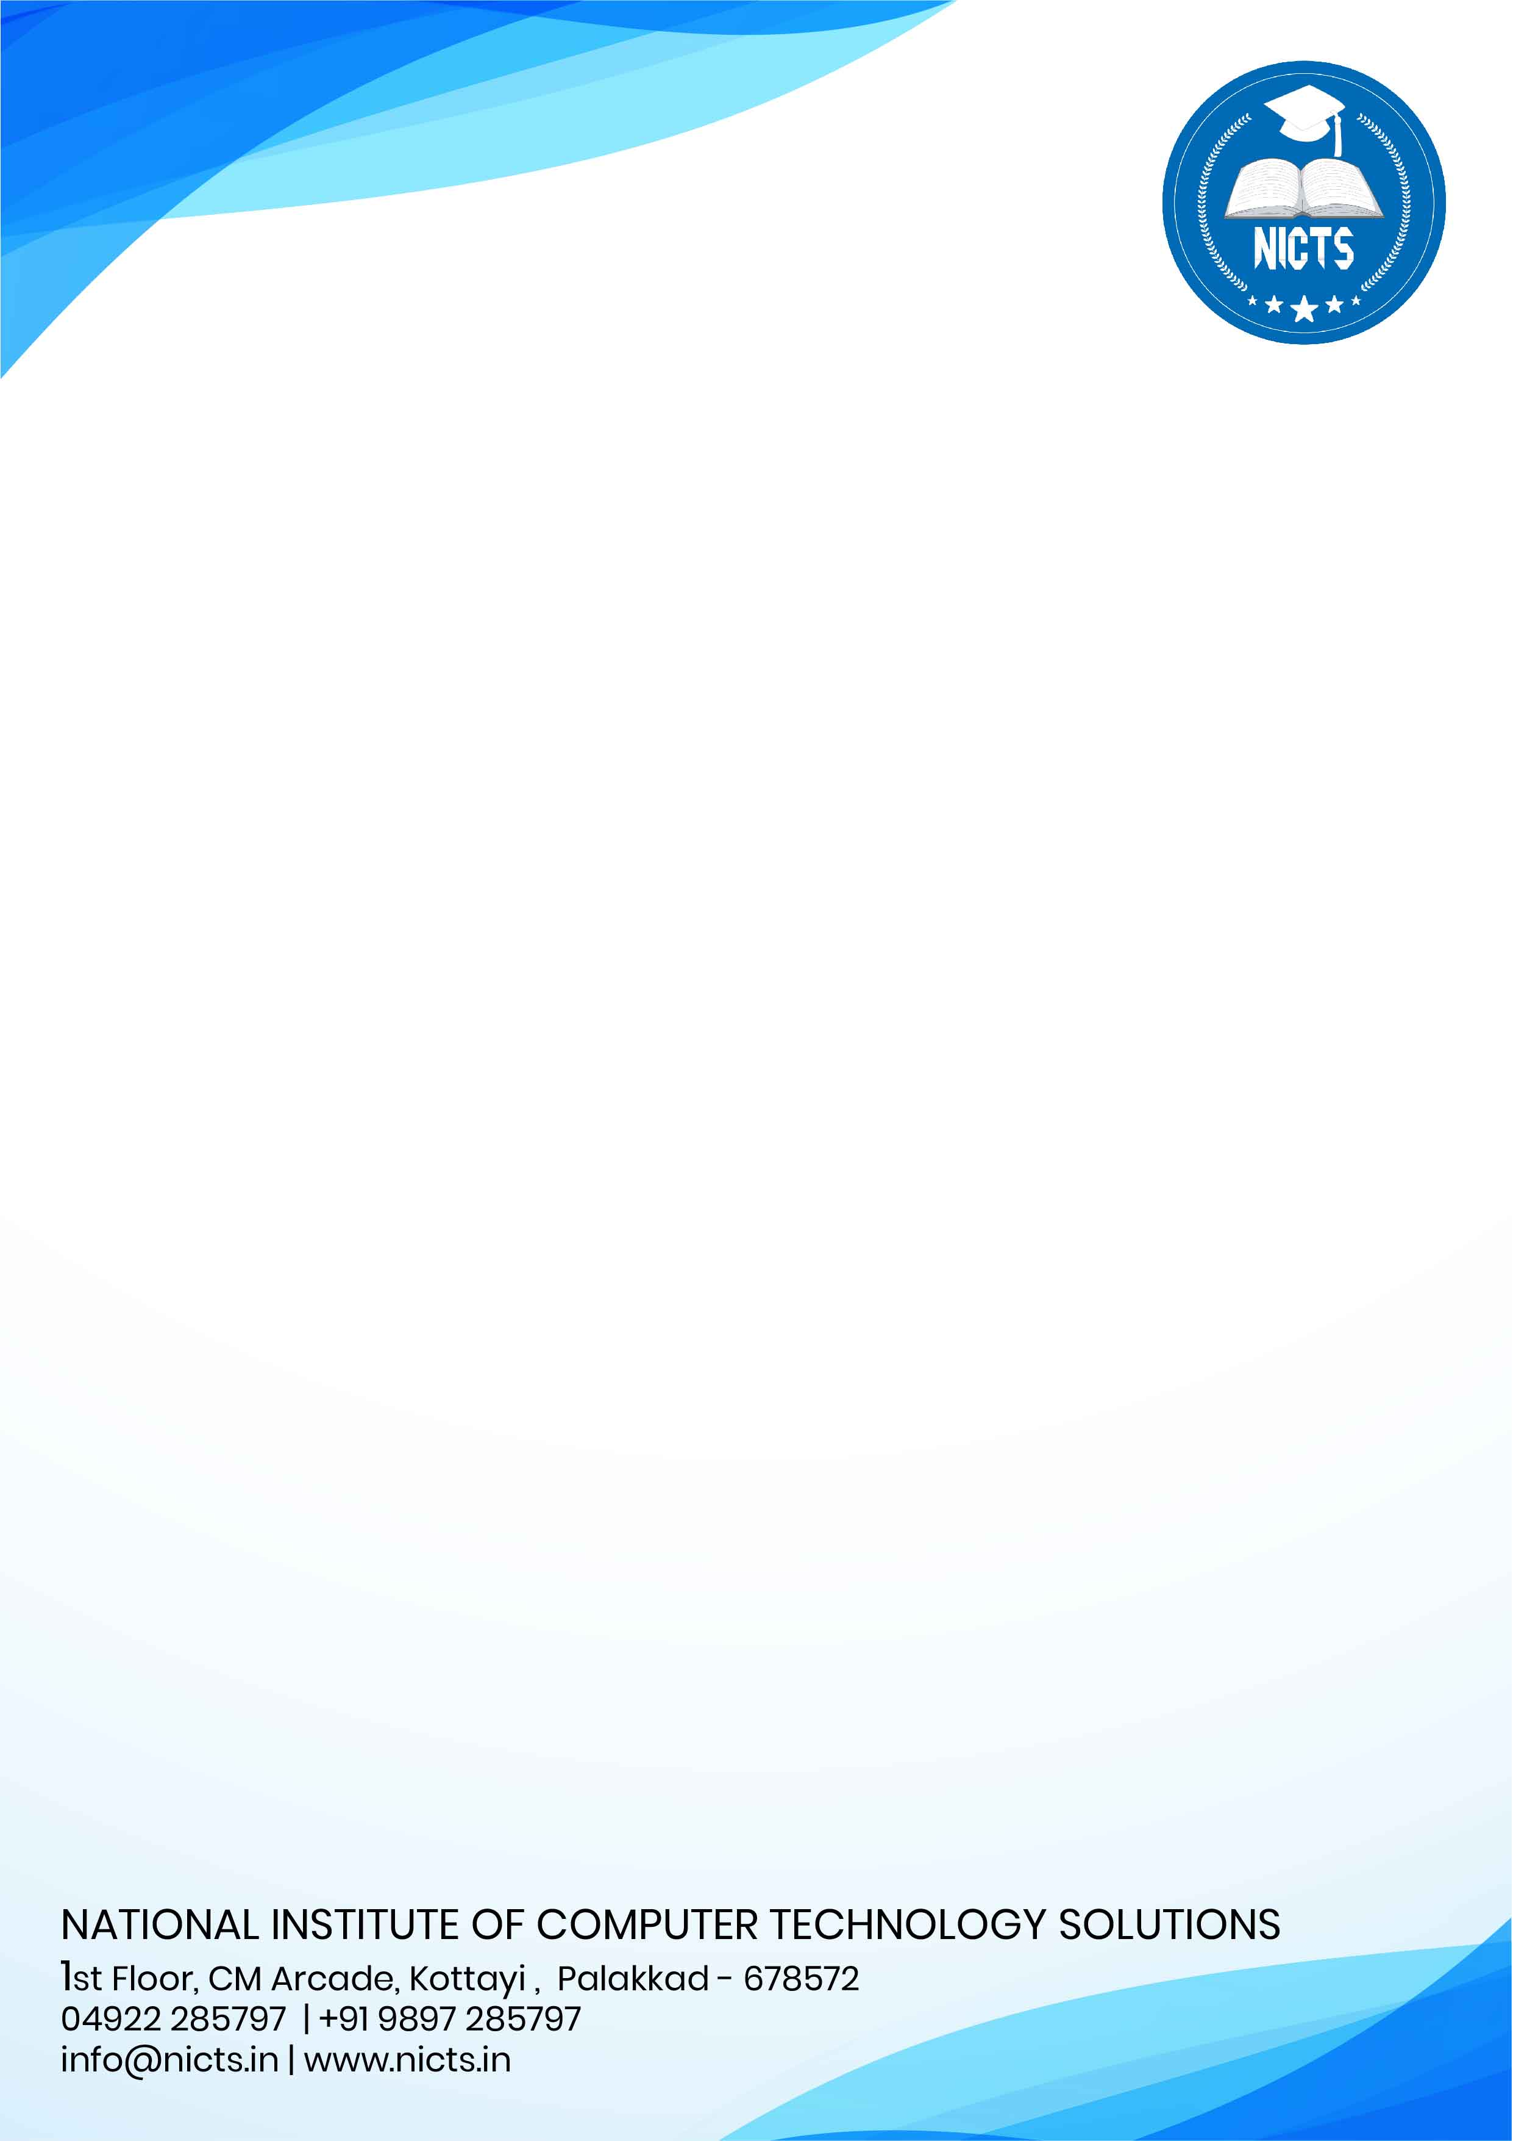

Date: 21/05/2025

Place: Kottayi, Palakkad.

**CERTIFICATE**

This is to certify that **Ms. SHAMSEENA V (CYAXMCS003),** MSc Computer Science student of **CHERPULASSERY COLLEGE OF SCIENCE AND TECHNOLOGY**, **KARALMANNA**, **PALAKKAD**, Kerala has successfully completed six months project work entitled **“FAKE NEWS DETECTION USING DIFFERENT MACHINE LEARNING ALGORITHMS IN RANDOM FOREST, SVM, KNN, AND XGBOOST"** from **January 2025 to June 2025**. During this period of her project she has taken keen interest to study various aspects of the project and with us she found punctual, hardworking and inquisitive. During this period her performance was good and we wish good luck for her future endeavours.

For **NICTS**

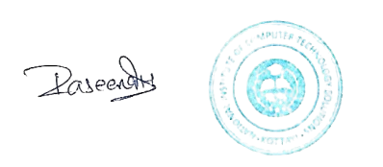

RASEENA H

Project Manager

